**VE373 Microprocessor Based System Design**

**Lab 6. Serial Communication - UART**

1. **Objective**

* Learn how to communicate with another device using standard protocols
* Learn how to configure and use a UART module

1. **Project Description**

In this lab, you are asked to configure one of the six UART modules in the STM32F103C8T6 MCU to function as a full-duplex transmitter and receiver, then to establish a serial communication channel between your STM32F103C8T6 mini board P1 (DB9_M) and you PC by a USB_RS232 cable ,the schematics connecting refer to figure 1 .



Figure 1 STM32F103C8T6 UART Schematics Connecting Diagrams

Other parts of the wiring are same as LAB 5 (Analogue to Digital Converter) , please refer to Figure 2 , Lab 6 Pinout & Configuration as below and



Figure 2 Pinout & Configuration

Figure 3. Connecting and wiring with PC,STM32F103C8T6 developing Board and LCD1602 shows the system connecting between the devices.



Figure 3. Connecting and wiring with ComputerSTM32F103C8T6

In this Lab , PB0 is configured as ADC input , PA9 is configured as USART1_Tx and PA10 is configured as USART1_Rx. A USB-RS232 cable connect the STM32F103C8T6 developing board to Computer (PC). The communication simulation tool of fireTools.exe is installed in PC. The communication tool can receive data and transmit order to STM32F103C8T6 developing board. You are required to develop software to receive the orders from fireTools.exe (in the PC ) and transmit the ADC converted data to PC accordingly .In the Demonstration software ,the testing tool sends characteristics of ‘A’ to STM32F103C8T6 board , STM32 receives ‘A’ and transmits the decimal ADC voltage results with UART communication .When testing tool send characteristics of ‘B’ to the STM32 developing board , the direct ADC result will be sent to PC . If the developing board receive the order from the tools other than ‘A’ or ‘B’, then “Send Correct Order ,Please!” will be transmitted to PC with UART communication . Please read Figure 4 for detail .



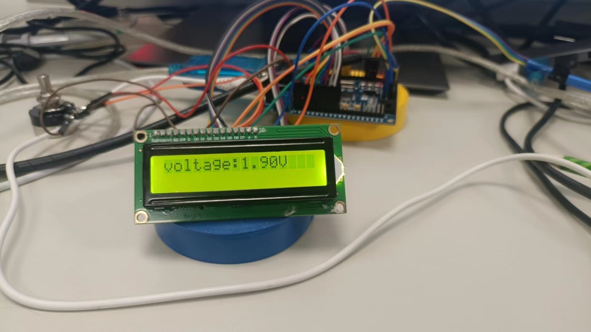





Figure 4 Receive and send ADC results with vary orders through UART communication

**DELIVERABLES**

One submission is required for each team and should be submitted electronically by one of the team members. Make sure names of all team members are clearly shown in the file. Each submission should include:

* 1. Lab report, including a brief discussion of the lab, software development work (such as algorithms, pseudo code, flow charts, etc.), answers to questions if asked in the lab manual, test plan, test results, as well as all your source codes.
  2. Evaluation report, each student should also submit an evaluation to describing your own contribution to the lab and to evaluate the performance of every other team member.
  3. Zipped working directory for your project
  4. Any other related documents

**NOTE**: A team must successfully demonstrate their lab results to receive full credits. Although it may need two teams to demonstrate the lab results together, each team must work individually and separately. A team that can’t find another team with fully functioning board to demonstrate may communicate with the lab instructor’s system.

**GRADING**

Total points: 200 points. The lab will be graded as follows:

Lab Report and Evaluation 20%

Executable program 20%

Demonstration 30%

On time completion 20%

Peer Evaluation Report 10%

Peer evaluation form:

|  |  |  |
| --- | --- | --- |
| Name | Percentage of contribution  (sum to 100%) | Responsibilities |
| (yourself) |  |  |
| (your lab partner) |  |  |
| (your lab partner) |  |  |

**DUE DATE**

The lab should be demonstrated to the TAs before your lab session is over.

The lab report and evaluation report is due by **10:00pm of August , 2024**.

*Note: the UART simulation tool is attached as below . You can open the folder and run fireTool.exe directly without installation.

